AI Avatar Setup & Prompt Guide
(Select "Create Image", upload a character sheet, or enter/paste your prompt below:)
🎯 Detailed Image Prompt
Ready-to-Copy Image Prompt:
Create a highly photorealistic, ultra-clean 16:9 horizontal studio photograph of the exact same man shown in the reference image. Preserve his facial identity, face shape, hairstyle, skin tone, glasses, beard/stubble, body proportions, and overall appearance exactly as the reference.
The man is sitting comfortably on a modern white office chair, positioned centrally behind a large spotless white table. He is facing directly toward the camera with a natural, calm and confident expression. His posture is relaxed and professional. One hand is gently resting under his chin, while the other arm rests naturally near the laptop. He is wearing the same muted sage-green full-sleeve sweatshirt, same fit and texture, with the same dark smartwatch on his wrist and the same thin transparent/blue-tinted eyeglasses.
Place a silver Apple MacBook open on the table directly in front of him. The MacBook should be realistic, premium metallic silver, sharp and clearly visible, positioned naturally without covering his face or upper body.

🏢 Background Specifications
• Wall: Completely plain pure-white wall
• Allowed Elements: Only the man + white chair + MacBook + white table + white wall
• Prohibited Elements: No YouTube logo, no “YouTube Studio” text, no posters, no shelves, no books, no cup, no mobile phone, no notebook, no microphone, no decorations, no plants, no extra objects
💡 Lighting & Quality Settings
• Lighting: Bright professional studio lighting, soft evenly distributed light, subtle natural shadows
• Environment: Very clean white environment
• Textures: Realistic skin texture, realistic fabric texture, realistic hair strands, accurate glasses reflections
• Quality: Premium photography look, extremely sharp focus, high dynamic range, natural proportions, 8K/16K ultra-detailed quality, no blur, no noise, no artificial-looking skin
📐 Framing & Composition Rules
• Framing: 16:9 horizontal framing
• Camera & Focus: Man centered, camera at eye level, medium-wide shot, enough white negative space around him
• Visibility: Table visible across the lower portion of the frame, chair clearly visible behind him
• Composition: Symmetrical professional composition
⚠️ Important Constraints: Absolutely no text, logos, watermark, extra furniture, extra people, or unnecessary objects. Keep the scene minimal, bright, white and extremely clean.

🖼️ Reference & Generated Samples
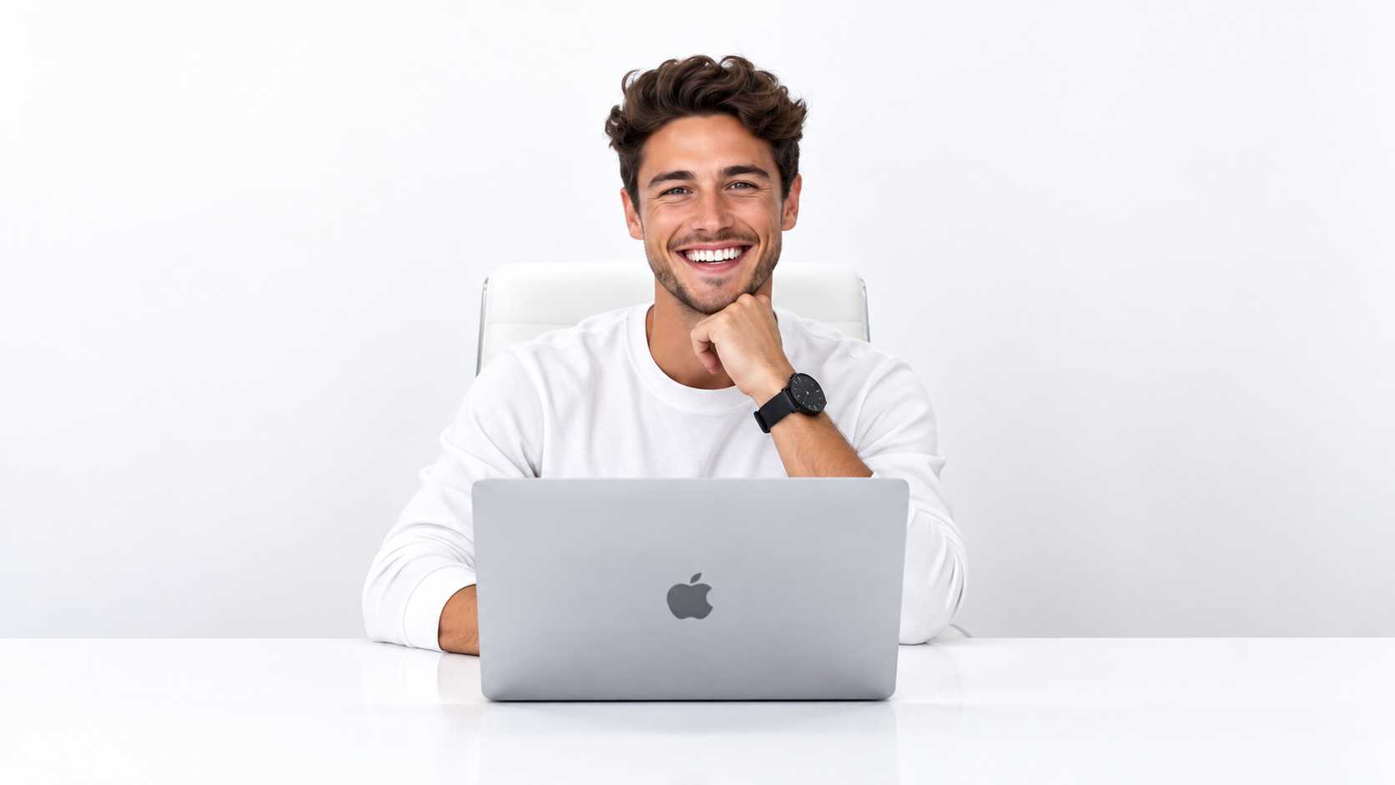
Reference Sample 1: Character Sheet / Facial Identity Angles
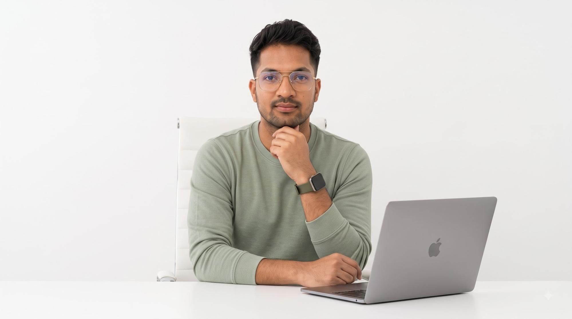
Reference Sample 2: Generated 16:9 Horizontal Studio Setup
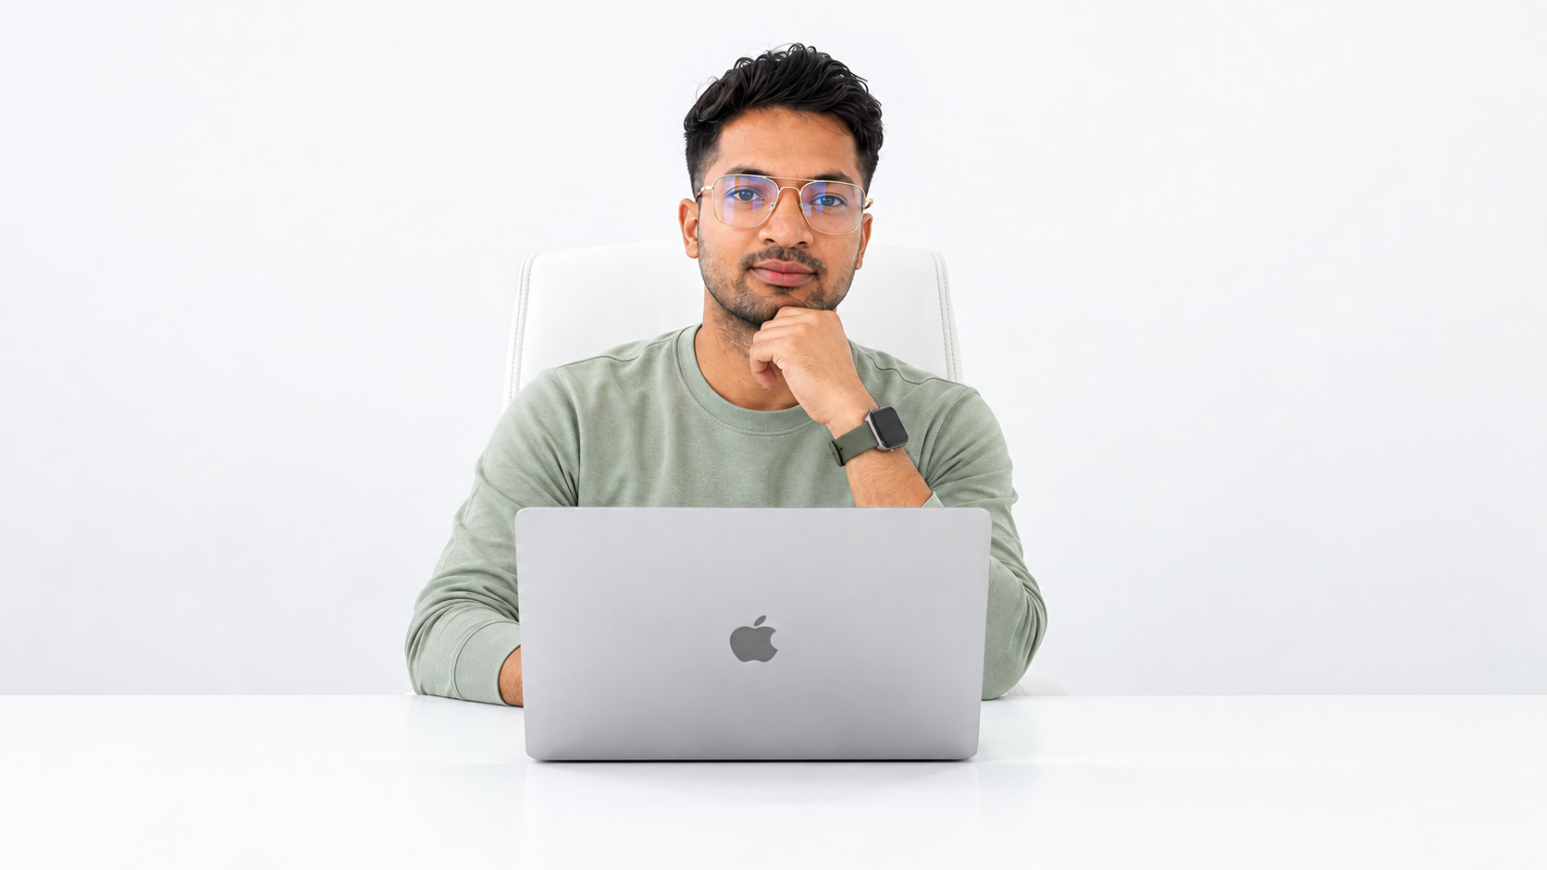
Reference Sample 3: High-Fidelity Character Render
🎬 VIDEO TUTORIAL / आधिकारिक वीडियो ट्यूटोरियल
▶️ Create a Realistic Talking AI Avatar for Faceless YouTube Channel (FREE)
🌐 Video URL: https://youtu.be/o-8F-89cmZA?si=zois_GjY5Tpld8y7
(Google Docs Tip: Place cursor over the URL and press TAB to convert it into an official interactive YouTube Smart Chip with preview).

Video Prompt
AI Avatar
📋 Instruction
1. Paste your script in SCRIPT.
2. Copy the full video prompt.
3. Open Google Flow.
4. Upload and select Character Sheet + AI Avatar.
5. Paste the prompt and Create Video.
🎬 Video Prompt
Ready-to-Copy Master Video Director Prompt:
# ROLE
You are an expert AI video generation director, photorealistic AI avatar animator, cinematic YouTube studio videographer, and realistic human motion specialist.
# PRIMARY OBJECTIVE
Create a highly photorealistic talking-head video using the up loaded creator reference image as the EXACT visual identity and scene reference. The uploaded image is the SINGLE SOURCE OF TRUTH for the creator’s:
Face identity
Facial structure
Skin tone and texture
Hairstyle
Hairline
Facial hair
Age appearance
Body proportions
Clothing
Accessories
Desk setup
Microphone
Laptop
Studio/background
Lighting
Camera framing
Overall visual appearance
Do NOT redesign, reinterpret, beautify, replace, or alter the creator or environment.
# REFERENCE IMAGE LOCK
Use the uploaded creator image as the exact starting visual reference.
The generated character MUST remain recognizably the SAME PERSON throughout the entire video.
STRICT IDENTITY PRESERVATION:
Do not change the face.
Do not generate a different person.
Do not alter facial proportions.
Do not change eyes, eyebrows, nose, lips, jawline, cheekbones, ears, or chin.
Do not change skin tone.
Do not change hairstyle or hairline.
Do not change facial hair.
Do not make the person younger or older.
Do not apply beauty filters.
Do not create an AI-looking face.
Do not morph the face between frames.
Do not introduce facial inconsistencies.
Do not change clothing.
Do not add or remove accessories.
The person must look like the exact creator shown in the uploaded image, as if the original photograph has been realistically brought to life.
# BACKGROUND / ENVIRONMENT LOCK
Preserve the uploaded image’s environment EXACTLY.
The:
studio
walls
furniture
desk
microphone
laptop
props
background objects
decorations
lighting setup
shadows
depth of field
color temperature
spatial arrangement
must remain consistent with the uploaded image.
DO NOT:
redesign the studio
change the background
add new objects
remove existing objects
move furniture
change the microphone
change the laptop
alter the desk
replace background elements
generate a different room
introduce visual distractions
The environment should feel like the exact same physical location shown in the reference image.
# SCRIPT
Generate the creator’s performance according to the following script:
[PASTE YOUR VIDEO SCRIPT HERE]
The creator must naturally deliver the provided script as if they are genuinely speaking to the camera.
The speech must follow the script accurately and in the correct order.
Do not add extra dialogue.
Do not remove important dialogue.
Do not paraphrase unless absolutely necessary for natural speech.
Do not create subtitles unless specifically requested.
# TALKING PERFORMANCE
The creator should behave like a professional YouTube educator/presenter explaining the topic directly to the audience.
Speech should feel:
Natural
Confident
Conversational
Clear
Professional
Engaging
Human
Authentic
Avoid robotic AI-avatar behavior.
Use realistic speech timing, natural pauses, emphasis, and conversational rhythm based on the script.
# LIP-SYNC
Synchronize the creator’s mouth movements precisely with the spoken script. Mouth movement must be:
Natural
Physically realistic
Properly synchronized with phonemes
Subtle and human
Consistent with the creator’s identity
Do NOT exaggerate mouth movement.
Do NOT distort the lips.
Do NOT change the shape of the mouth unnaturally.
Do NOT introduce facial warping during speech.
The creator’s mouth must return naturally to a relaxed neutral position during pauses.
# FACIAL PERFORMANCE
Maintain the exact facial identity from the reference image while allowing subtle natural facial expressions appropriate to the spoken script. Allowed:
Natural blinking
Subtle eyebrow movement
Slight eye movement
Small head movements
Mild expression changes
Natural breathing
Subtle engagement while speaking
Expressions must remain restrained and realistic.
Do NOT overanimate the face.
Do NOT exaggerate emotions.
Do NOT make the creator smile continuously.
Do NOT create cartoon-like facial animation.
# HAND GESTURES
The creator must use natural hand gestures while explaining the script.
Gestures should feel like those of a real YouTube educator speaking naturally. Use subtle gestures such as:
Open-palm gestures
Small forward hand movements
Gentle finger emphasis
Light wrist movements
Small pointing gestures when contextually appropriate
Brief counting gestures when listing points
Hands moving slightly toward the camera when emphasizing an important idea
Natural hand separation and repositioning
Occasional resting position
Gesture intensity should automatically respond to the meaning and emphasis of the script.
IMPORTANT:
Do NOT make random gestures continuously.
Do NOT exaggerate arm movements.
Do NOT wave hands aggressively.
Do NOT move hands unnaturally fast.
Do NOT create extra fingers.
Do NOT deform hands.
Do NOT create duplicated hands.
Do NOT let hands merge with the desk, laptop, microphone, or other objects. Gestures should remain within a realistic area around the upper torso and desk.
# BODY MOTION
The creator remains seated behind the desk throughout the video. Allow only subtle, realistic upper-body movements:
Gentle breathing
Small posture adjustments
Slight shoulder movement
Tiny natural head nods
Small forward/backward posture shifts
Natural eye movements
Subtle body engagement while speaking
The body must remain anatomically stable.
No exaggerated body movement.
# CAMERA
Start from the exact visual composition suggested by the uploaded reference image.
Eye-level medium shot.
The creator remains the primary focal point.
Maintain realistic DSLR/cinematic depth of field.
## CAMERA ROTATION
During the FIRST 2 SECONDS:
Perform ONE continuous, extremely smooth dolly-orbit movement toward the LEFT side of the creator.
Move exactly 45 degrees around the subject.
Maintain:
Same camera height
Same approximate camera-to-subject distance
Same subject scale
Same lens perspective
Same vertical framing
The movement must be smooth and cinematic.
At exactly 45 degrees:
STOP the camera completely.
For the REMAINING duration of the video:
The camera must remain completely LOCKED OFF.
There must be:
No additional orbit
No camera rotation
No camera shake
No zoom
No dolly movement
No pan
No tilt
No reframing
No return movement
The final frame must remain at the 45-degree front-left composition.
# IMPORTANT CAMERA PRIORITY
The creator’s identity and environment are more important than cinematic camera movement.
If necessary, prioritize:
Exact face identity
Exact creator appearance
Exact background/environment
Natural human motion
Accurate lip-sync
Natural hand gestures
Camera movement
Never sacrifice identity preservation for camera movement.
# LIGHTING
Preserve the lighting characteristics of the uploaded reference image. Maintain:
Same overall lighting direction
Same warm cinematic tone
Natural skin rendering
Realistic highlights and shadows
Consistent background illumination
Shallow depth of field
Do not dramatically change the lighting during the video.
# OBJECT CONSISTENCY
The microphone, laptop, desk, chair, and background objects must remain physically consistent throughout the shot.
No object morphing.
No object duplication.
No disappearing objects.
No floating objects.
No changing object shapes.
No background reconstruction.
# REALISM
The final video should look like a real professional YouTube creator was recorded with a high-end DSLR/cinema camera.
Target visual quality:
Photorealistic
Natural skin texture
Realistic human anatomy
Realistic hands
Realistic eye movement
Realistic blinking
Natural lip-sync
Physically plausible body movement
Cinematic depth of field
Professional studio recording quality
It must NOT look like:
AI-generated avatar
3D character
Digital human
Cartoon
Deepfake-style face morph
Plastic skin
Over-smoothed face
Robotic presenter
# CONTINUITY
Maintain perfect temporal consistency throughout the entire video.
The creator’s identity must remain unchanged from beginning to end. No:
Face morphing
Identity drift
Hairstyle changes
Clothing changes
Skin-tone changes
Facial-feature changes
Background changes
Lighting flicker
Object morphing
Hand deformation
Body distortion
# FINAL VIDEO BEHAVIOR
The final result should feel like:
”The exact creator from the uploaded image was sitting in the exact same studio and naturally recorded this video while explaining the provided script.”
The creator speaks naturally, maintains eye contact with the camera, uses appropriate hand gestures while explaining important points, and behaves like a real professional YouTube presenter.
The video should feel authentic, polished, cinematic, and human — NOT like an AI avatar.
# NEGATIVE INSTRUCTIONS ⚠️
Do not change the creator’s face.
Do not change the creator’s identity.
Do not change the background.
Do not redesign the studio.
Do not change clothing.
Do not change hairstyle.
Do not alter facial proportions.
Do not introduce another person.
Do not create exaggerated facial expressions.
Do not create exaggerated hand gestures.
Do not create unnatural body movement.
Do not distort hands or fingers.
Do not create extra fingers.
Do not create duplicated limbs.
Do not create mouth deformation.
Do not create lip-sync errors.
Do not create robotic motion.
Do not add subtitles.
Do not add text or graphics.
Do not add camera movement after reaching 45 degrees.
Do not orbit beyond 45 degrees.
Do not rotate back.
Do not zoom.
Do not pan or tilt.
Do not change the final composition.
PRIORITY:
EXACT CREATOR IDENTITY + EXACT ENVIRONMENT + SCRIPT ACCURACY + NATURAL HUMAN PERFORMANCE + NATURAL HAND GESTURES + PHOTOREALISM.

YouTube Video Help
Video Resources
🎬 Featured Video Tutorial
Learn how to create a realistic talking AI avatar for your faceless YouTube channel completely for free with this step-by-step guide.
▶ Watch on YouTube: Create a Realistic Talking AI Avatar for Faceless YouTube Channel (FREE)
🌐 URL: https://youtu.be/o-8F-89cmZA?si=zois_GjY5Tpld8y7

AI Avatar Video Prompts (15 Variations)
Variation 1 - Billionaire Tech Founder Vibe
Ready-to-Copy Video Prompt:
@is sitting in a Professional cinematic interview setup, ultra luxury modern penthouse studio with floor-to-ceiling city-view windows at night, warm practical lamps, blurred skyline lights in background, cinematic soft depth of field, seated confidently in a premium leather chair, high-end documentary lighting, realistic skin tones, shallow DOF, billionaire tech founder aesthetic, dark charcoal and warm amber color palette, ultra realistic, Clothing: fitted black turtleneck with luxury minimal styling, expensive watch, clean modern look, natural hand gestures while speaking, talking directly into the camera lens in Hindi, ”SCRIPT”

Variation 2 - Elite AI Creator Studio
Ready-to-Copy Video Prompt:
@is sitting in a Professional cinematic interview setup, futuristic AI creator workspace with glowing practical lights, blurred RGB panels, floating monitor reflections and modern shelves in background, cinematic shallow depth of field, seated confidently, premium documentary lighting, realistic skin tones, ultra detailed, luxury creator aesthetic, neon green and matte black color palette, ultra realistic, Clothing: oversized dark grey tech wear hoodie layered with premium black jacket, modern futuristic fashion styling, natural hand gestures while speaking, talking directly into the camera lens in Hindi, ”SCRIPT”

Variation 3 - Warm Hollywood Interview Look
Ready-to-Copy Video Prompt:
@is sitting in a Professional cinematic interview setup, elegant Hollywood-style interview room with warm tungsten practical lighting, blurred luxury decor, wooden textures and soft lamp glow in background, cinematic shallow DOF, seated confidently, premium documentary lighting, realistic skin tones, rich warm-orange and brown tones, ultra realistic, Clothing: fitted cream full-sleeve sweater with sophisticated minimal styling, luxury casual aesthetic, natural hand gestures while speaking, talking directly into the camera lens in Hindi, ”SCRIPT”

Variation 4 - Modern Entrepreneur Podcast Setup
Ready-to-Copy Video Prompt:
@is sitting in a Professional cinematic interview setup, premium podcast studio with aesthetic wooden panels, warm desk lamps, blurred microphones and modern decor in back ground, cinematic depth of field, seated confidently at a luxury desk setup, realistic skin tones, shallow DOF, ultra realistic, Clothing: beige overshirt layered over white t-shirt, premium entrepreneur fashion aesthetic, modern classy styling, natural hand gestures while speaking, talking directly into the camera lens in Hindi, ”SCRIPT”

Variation 5 - Cozy Luxury Home Office
Ready-to-Copy Video Prompt:
@is sitting in a Professional cinematic interview setup, cozy luxury home office with warm sunset light entering through large curtains, aesthetic bookshelf, indoor plants and practical lamps in background, cinematic soft depth of field, seated confidently, premium documentary lighting, realistic skin tones, ultra realistic, warm beige and caramel color palette, Clothing: soft brown knit sweater with relaxed luxury styling, elegant creator fashion aesthetic, natural hand gestures while speaking, talking directly into the camera lens in Hindi, ”SCRIPT”

Variation 6 - Viral YouTube Creator Setup
Ready-to-Copy Video Prompt:
@is sitting in a Professional cinematic interview setup, high-end YouTube creator room with soft RGB practical lights, blurred gaming monitor glow, cinematic shelves and modern tech setup in background, shallow depth of field, seated confidently, premium documentary lighting, realistic skin tones, ultra realistic, bold contrast and cinematic shadows, Clothing: oversized black streetwear hoodie with premium modern creator styling, trendy casual fashion aesthetic, natural hand gestures while speaking, talking directly into the camera lens in Hindi, ”SCRIPT”

Variation 7 - Minimal Apple-Style Studio
Ready-to-Copy Video Prompt:
@is sitting in a Professional cinematic interview setup, ultra minimal premium studio with soft ambient lighting, clean beige walls, blurred modern furniture and subtle practical lamp glow in background, cinematic shallow depth of field, seated confidently, realistic skin tones, luxury Apple-commercial aesthetic, ultra realistic, Clothing: fitted off-white crewneck sweatshirt with premium minimal fashion styling, clean modern luxury look, nat ural hand gestures while speaking, talking directly into the camera lens in Hindi, ”SCRIPT”

Variation 8 - Dark Cinematic Filmmaker Setup
Ready-to-Copy Video Prompt:
@is sitting in a Professional cinematic interview setup, dark moody filmmaker studio with warm spotlight practical lighting, blurred cinema camera gear and vintage decor in back ground, cinematic shallow DOF, seated confidently, premium documentary lighting, realistic skin tones, dramatic shadows, ultra realistic, Clothing: charcoal black button-up shirt with rolled sleeves, sleek filmmaker aesthetic, premium masculine styling, natural hand gestures while speaking, talking directly into the camera lens in Hindi, ”SCRIPT”

Variation 9 - Mountain Town Travel Vlog
Ready-to-Copy Video Prompt:
@is walking through a beautiful clean mountain town street, charming cafes, wooden architecture, scenic hills in the background, crisp morning sunlight, cinematic travel vlog style, handheld camera feel, shallow depth of field, premium documentary aesthetic, ultra realistic, Clothing: olive green utility jacket over a white t-shirt, beige chinos and clean sneakers, natural hand gestures while talking directly into the camera in Hindi, ”SCRIPT”

Variation 10 - Luxury Marina Vlog
Ready-to-Copy Video Prompt:
@is walking beside a luxury marina with yachts and modern waterfront buildings in the background, golden hour lighting, cinematic lifestyle vlog atmosphere, shallow depth of field, premium creator aesthetic, realistic skin tones, ultra realistic, Clothing: light blue linen shirt with rolled sleeves, white trousers and stylish sunglasses, talking directly into the camera in Hindi, ”SCRIPT”

Variation 11 - Beautiful Park Vlog
Ready-to-Copy Video Prompt:
@is walking through a lush green city park with wide pathways, modern skyline visible in the distance, warm sunlight filtering through trees, cinematic vlog style, handheld creator camera perspective, shallow depth of field, ultra realistic, Clothing: fitted beige polo t-shirt, dark jeans and white sneakers, natural expressions while talking directly into the camera in Hindi, ”SCRIPT”

Variation 12 - Luxury Shopping District Vlog
Ready-to-Copy Video Prompt:
@is walking through a clean upscale shopping district with premium stores, aesthetic architecture and luxury storefronts in the background, cinematic creator vlog look, soft day light, shallow DOF, ultra realistic, Clothing: beige overshirt layered over a white t-shirt, black trousers and modern sneakers, entrepreneur creator aesthetic, talking directly into the camera in Hindi, ”SCRIPT”

Variation 13 - Old European Street Vlog
Ready-to-Copy Video Prompt:
@is walking through a picturesque cobblestone street with beautiful historic buildings, outdoor cafes and flower balconies, cinematic travel documentary vibe, soft afternoon sunlight, shallow depth of field, ultra realistic, Clothing: cream knit polo shirt with tailored trousers, classy travel creator style, talking directly into the camera in Hindi, ”SCRIPT”

Variation 14 - Riverside City Vlog
Ready-to-Copy Video Prompt:
@is standing beside a clean riverside promenade with modern bridges, skyline reflections and walking paths in the background, cinematic vlog atmosphere, golden-hour lighting, shallow depth of field, luxury lifestyle creator aesthetic, ultra realistic, Clothing: light brown bomber jacket over a black t-shirt, dark jeans and clean sneakers, natural hand gestures while talking directly into the camera in Hindi, ”SCRIPT”

Variation 15 - Futuristic Smart City Vlog
Ready-to-Copy Video Prompt:
@is walking confidently through a futuristic smart city plaza with modern architecture, digital billboards, clean urban design and glass skyscrapers in the background, cinematic tech creator vlog style, soft daylight, shallow depth of field, premium AI creator aesthetic, ultra realistic, Clothing: black techwear jacket, fitted black t-shirt, cargo pants and modern sneakers, talking directly into the camera in Hindi, ”SCRIPT”

